Big O notation is used to describe the efficiency of an algorithm by measuring how its running time or memory usage grows as the input size (n) increases.
It helps us:
- Compare different algorithms.
- Predict performance for large datasets.
- Choose the most efficient algorithm.

Linear Search
- Best Case: O(1) (element is the first item)
- Average Case: O(n)
- Worst Case: O(n) (element is last or not found)
Binary Search
- Best Case: O(1)
- Average Case: O(log n)
- Worst Case: O(log n)

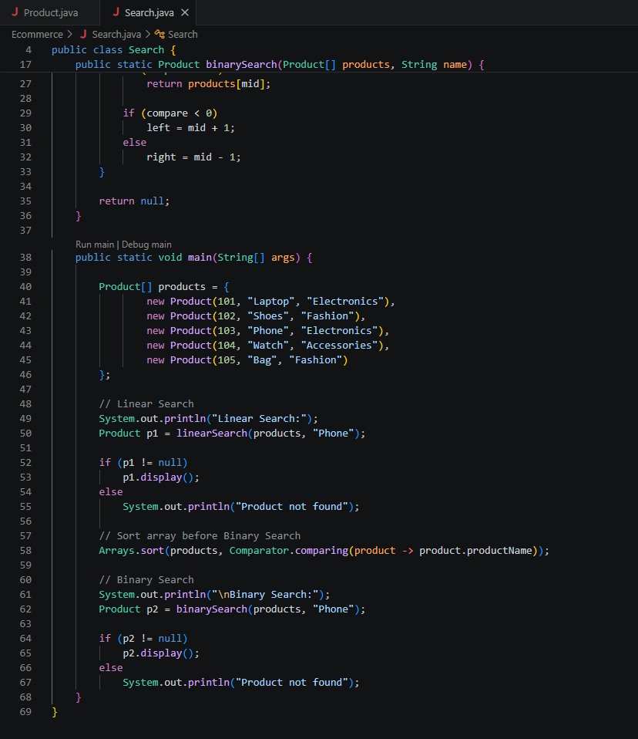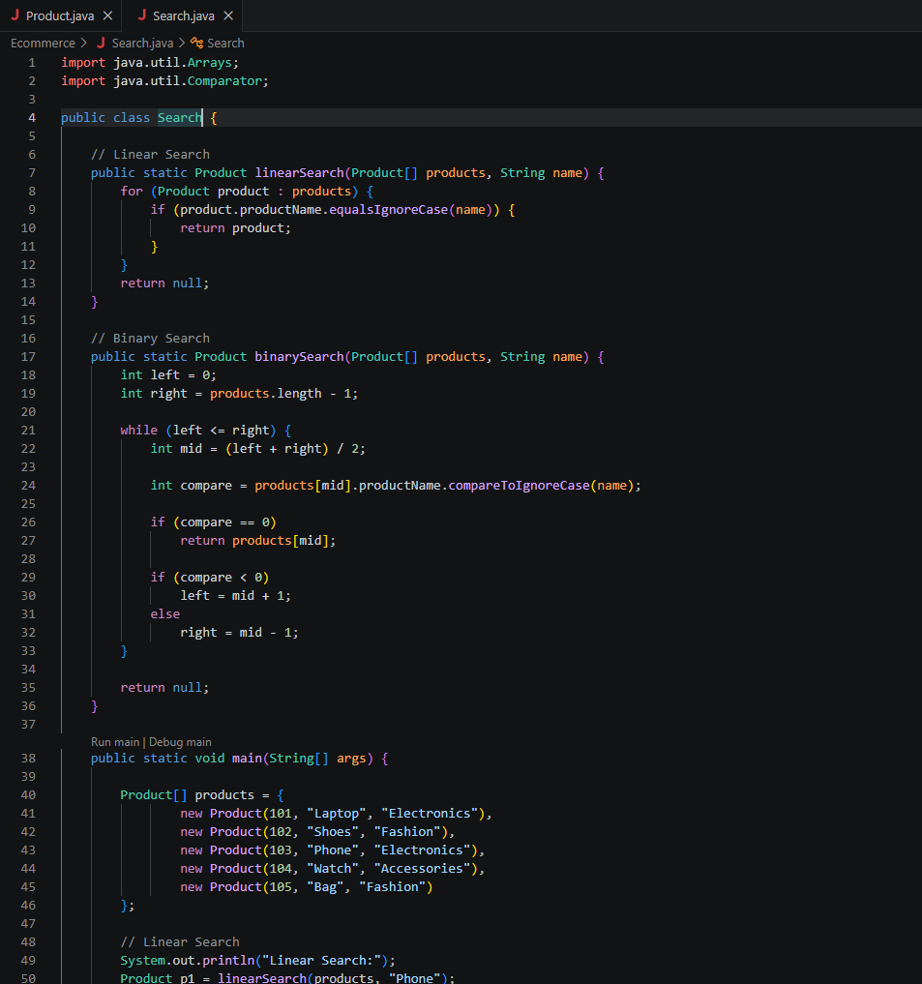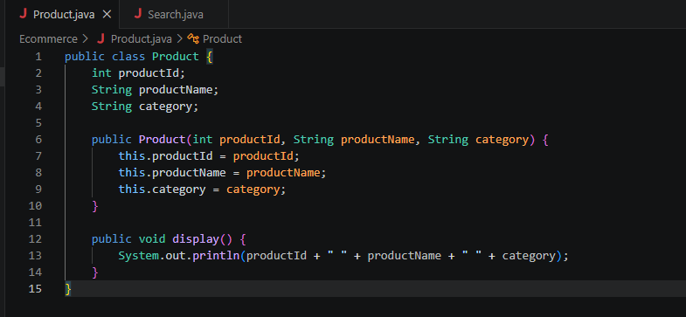

OUTPUT: